Quiz
Data Wires Part 1

Name:_________________________ Period:___ Date:________ Score:_____/15
- (2 pts.) How do you attach a Data Wire?

- Add a Data Wire node to the program and use its available connectors
- Select the two blocks to be attached with data wires, then go to Tools > Add Data Wires
- Drag a data output plug connector into a data input slot
- Use the “Draw Data Wires” button and draw data wires from block to block, connecting output ends to input ends.

- (6 pts.) Describe each block in this program and describe what the program will do:
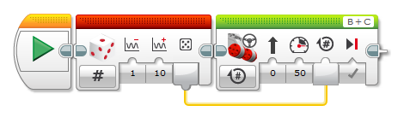

- (6 pts.) Describe each block in this program and describe what the program will do:
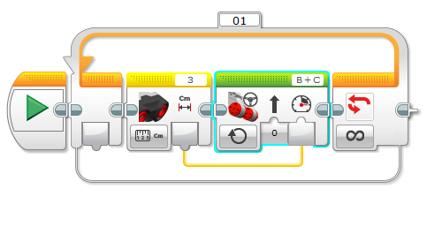
- (3 pts.) Without the Loop, turning the wheel had no effect on the displayed number because…
